Chapter 11, Solution 43.

Design a problem to help other students to better understand complex power.

Although there are many ways to work this problem, this is an example based on the same kind of problem asked in the third edition.

Problem
The voltage applied to a 10-ohm resistor is
v(t) = 5 + 3 cos(t + 10°) + cos(2t + 30°) V
- Calculate the rms value of the voltage.
- Determine the average power dissipated in the resistor.

Solution

(a) 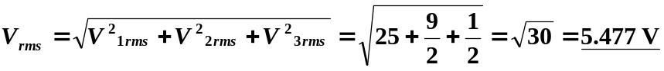
(b) 